Joynal Abedin

FY9237

CSC 4421

FALL 2017

SECTION 001

L10

1. Yes, the sum of these equals the total number of disk blocks on the disk. df command reports the file system disk space usage.

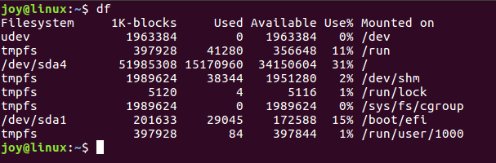

2. Screenshot included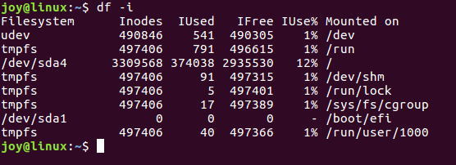

3. Screenshot included (2x Screenshots included)

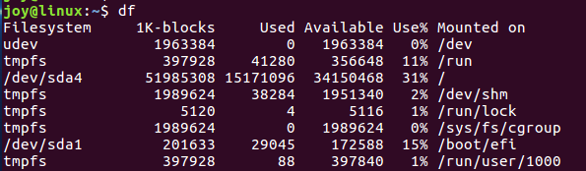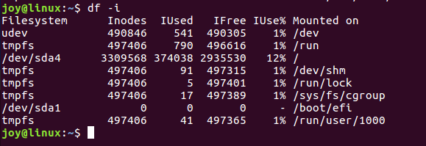

4. I created a file with just a few characters in it. I didn’t notice significant change. File system tmpfs and /dev/sda1 changed slightly.

5. I have increased the size of this new file by entering a large number of characters which is greater than 5 thousand. Yet no significant change has been noticed other than file system increased in size a little. Refer to screenshot. (2x Screenshots) 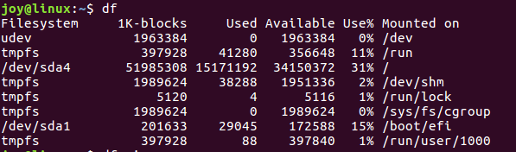

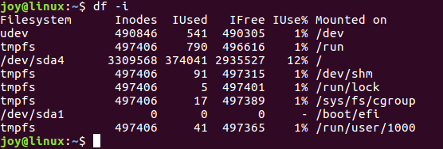

6. I repeated the last step, however, this time I entered more characters. Screenshots are listed below. I noticed a little change on the file system. (2x Screenshots)

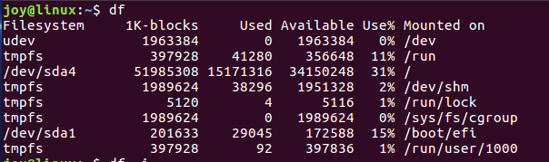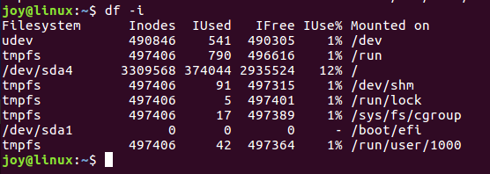

7. I repeated the previous step but entered more characters. There’s a increase in size in the file system. Other than that I don’t see much differences. (2x Screenshots)

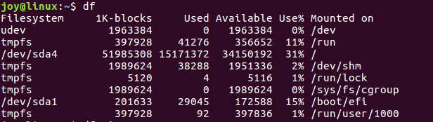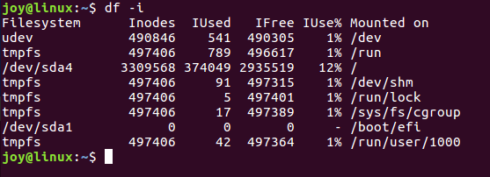

8. df shows information about the file system on which each file resides or all file system by default. The effect of increasing in the size of newly created file wasn’t much, however, it had impact on the file system. The result has changed as the file size has increased by couple thousands of characters.